Raghad Alghamdi

Activity 1

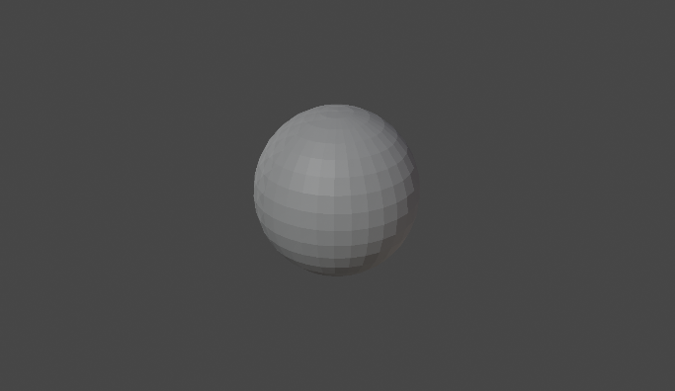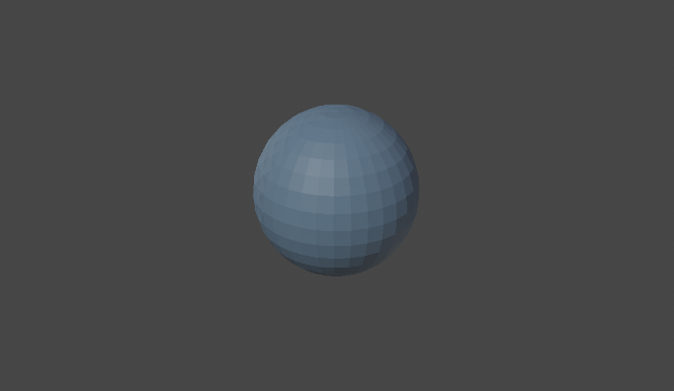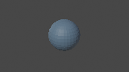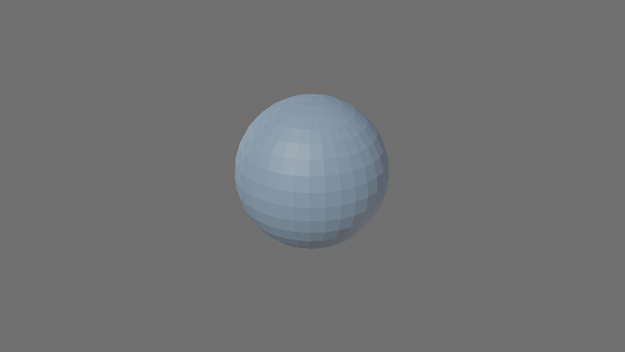

Checkpoint 1: Checkpoint 2:

Checkpoint 3:

Checkpoint 4:

Checkpoint 3 is smaller than Checkpoint 2 since it tries to maintain a high level of quality. This means the quality varies as the resolution is changed.

Checkpoint 5:

Checkpoint 6:

Checkpoint 2 is darker than Checkpoint 5, and Checkpoint 5 is brighter because the gamma value is more than Checkpoint 2 gamma value. This means that when the gamma value is high, the brighter the image is. The lower the gamma value, the darker the image is.

Questions:

1. How does light interact differently with different objects in real life? Give three examples?

* When the light wave with a single frequency impacts an item, a variety of things can happen. For example, a black shirt would absorb the heat if the light was exposed to the surface. The light wave may be absorbed by the object, in which case its energy is transformed to heat. In another case, the light wave might be reflected by the item. Also, the light wave may be transmitted by the item.

1. Why do objects appear to have different colors to our eyes?

* Due to the retina being covered with millions of light-sensitive cells called rods and cones, we are able to see different colors. Also, the color of the object can be seen in different shades due to the light exposer. When an object is exposed to much light, it may seem vibrant, but it may seem darker when exposed to little light.

1. What's the advantage of using YUV color space?

* Some benefits of using YUV include color television transmissions that are meant to be backward compatible with black-and-white television, which also applies to computers.

1. How are colors added differently for lights compared to paint? What does R+G+B equal to in each case?

* The R+G+B differentiation creates colors for light added that create white. In paint, other colors like yellow are added to show the R+G+B, and the R+G+B creates black.

1. Why are green screens green? Hint: think about the arrangement of color filters in front of the camera sensor.

* Green screens are green because it does not match any natural skin tone or hair color, where it is going to be easy to edit out.

1. Why is tone mapping needed for HDR images?

* Tone Mapping is used to simulate the look of pictures with a greater dynamic range than the reproducing media, such as prints or ordinary monitors.

1. What is the relationship between the wavelength of the light and the color of the light. E.g., why is the wavelength of 700nm associated with red, and 400nm associated with purple?

* Each color has a different wavelength which creates different colors. When they all get together, they make white. The wavelength of 700nm has a longer wavelength, which creates the color red, and 400nm has short wavelength and creates the color purple.